MNIST Tanh:

Not normalized (images in 0-255):

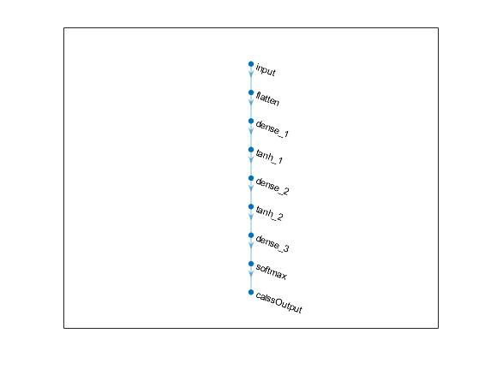

Validation accuracy: 88.05%

Test accuracy = 0.8757

MNIST Tanh:

Normalized (images in 0-1):



Validation accuracy: 88.84%

Test accuracy = 0.8828

